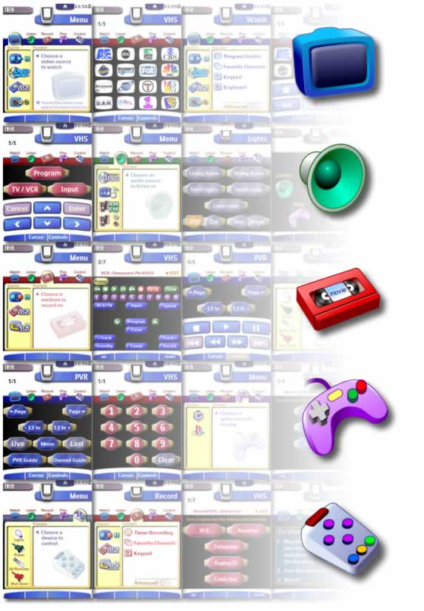

EasyTheater TM
CCF for Touch Screen Remotes • Version 1.2

EasyTheater is a trademark of Dale K. Crawford. Philips, Pronto, ProntoPro, and ProntoEdit are trademarks of Philips Electronics. Marantz and Touch Screen Setup are trademarks of Marantz.
The artwork and programming functionality of the EasyTheater.CCF files are copyrighted materials. For information on licensing these materials for commercial use, contact the author at darnitol@earthlink.net.

Copyright © 2002 Dale K. Crawford. All rights reserved.
LICENSE AGREEMENT
Individuals may use this file, or components thereof, free of charge for non-commercial personal applications only. Derivative works made by individuals must include an unedited copy of the Author Info device within Macro Groups. One additional panel may be added to the Author Info device bearing information about the non-commercial user of this file.
Any commercial use of this file is strictly prohibited without prior written permission from the author.
For a US $5 fee per remote, individuals or commercial users may license this file, which entitles you to remove the Author Info device. Payment can be made via www.paypal.com to darnitol@earthlink.net, or by contacting the author by e-mail.

AUTHOR INFORMATION
The original visual style and programming structure of this file were created by Dale K. Crawford. Derivative works may include any or all of the original design.
For information on licensing this file for commercial use, obtaining the source artwork files, or for requests for graphic design and/or user interface work related or unrelated to this file, please contact Dale Crawford at darnitol@earthlink.net.

Using EasyTheater
EasyTheater turns your TSR (touch screen remote) into an Activity-based remote control. Instead of merely recreating your pile of existing remotes on the screen of the TSR, EasyTheater combines the features of your various home theater components to create unique remote controls for each of the activities you do with your home theater.
For example, watching a DVD might use your DVD player for playback, your TV for display, and your receiver for sound. With EasyTheater, your TSR presents only the necessary buttons from these three remote controls. You’ll never waste time hunting for the right button, because EasyTheater always puts the ones you need right where you need them.

What You Need to Know
Pronto and Marantz TSRs are powerful, but programming them can be a challenge when you’re unfamiliar with ProntoEdit™ (Philips) or Touch Screen Setup™ (Marantz). EasyTheater reduces the amount of work you must do to have a full-featured remote control, but most of the work you do is still in ProntoEdit or Touch Screen Setup. Therefore, it’s important that you know how to use the software for your remote control before you attempt to modify EasyTheater to work with your touch screen remote.

Using Your Home Theater
The basic concept behind operating your home theater with EasyTheater is simple:
First, touch a Menu Icon to choose a type of activity.
Second, touch a Source Icon to choose a specific activity.
Third, touch a Function Icon to choose the controls for that activity.
From nearly any screen in EasyTheater, you can choose any home theater activity using this simple, three-step method.

Menu Icons
The Menu Icons are: Watch, Listen, Record, Play, and Control.
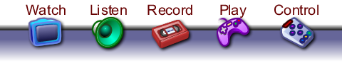
When you touch a Menu Icon, the icon grows larger, and a menu appears behind it. The menu contains two wells—one for Source Icons and one for Function Icons. Source Icons represent various home theater activities, while Function Icons represent the controls needed to perform those activities.
On color TSRs, Menu Icons each have a “theme color.” You’ll notice the color of each theme in many locations in EasyTheater, making it easy to know what sort of activity you’re performing at a glance. The theme color for the Menu Icons are:
Watch: Blue
Listen: Green
Record: Red
Play: Purple
Control: Steel

Source Icons
When a menu first displays, only the Source Icons appear, in the Source Well. Touch a Source Icon to select that activity. The TSR sends the IR macro that selects all of the relevant inputs and sources on your home theater, then displays Function Icons.

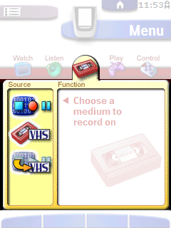
On grayscale TSRs with only 1MB of memory, such as the Pronto TSU1000 or the Marantz RC5000, the background color of the Source well and the Function well are the same color. To indicate which Source icon is selected on grayscale remotes, EasyTheater displays a gap in the bar that separates the two wells, immediately to the right of the Source icon. By letting the Source icon “flow” into the Function well, EasyTheater indicates the current Source.
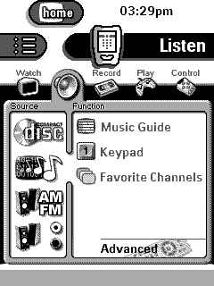
On TSRs with 2MB or more memory, the background behind the Source Icons inverts to indicate the current Source.
Tip: If your home theater setup is not as complex as the sample setup in EasyTheater, try modifying a 2MB grayscale version to see if you can optimize it to fit in your 1MB TSR. This allows you to take advantage of the highlighted Source Icons and the large icons on the Home panel.

Function Icons
Touch a Function Icon (or the text beside it) to display the controls for that function. For example, a numeric keypad appears when you touch a Keypad Function Icon.
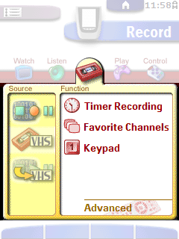

Controls
The screens that display buttons for controlling your home theater look very different than the menus you use to choose home theater activities. On these screens, you can use the various controls, use the hard buttons to toggle the Pop-Up controls (see the next section for more information), or use any of the Menu Icons to choose other activities.
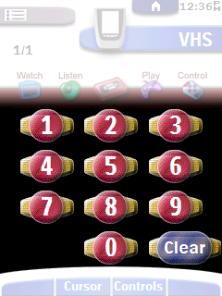
While you are enjoying a home theater activity, touch the Menu Icon for that activity at any time to display the list of Function Icons. Instead of returning to the “main menu,” touching a Menu Icon always displays the Function Icons for the current activity. You can, however, always select any Source Icon or another Menu Icon to select a different activity.

Pop-Up Controls
With EasyTheater, many home theater activities use two hard buttons on the face of the TSR to make it easy to navigate and control playback. When you press these buttons, your TSR displays a “Pop-Up” on top of the function screen you’re viewing. Press the button again to hide the Pop-Up.
You do not have to hide one Pop-Up before opening the other one. The Pop-Ups work independently, and either can be displayed at any time the button labels indicate that they are available.
For some activities, either the Cursor or Control Pop-up may contain the most important buttons. In such cases, the appropriate Pop-Up will appear when you choose the function. You can still close such Pop-Ups by pressing the corresponding hard button.
Tip: It’s easy to tell at a glance if the cursor and control Pop-Ups are available. For activities that use the Cursor and Control Pop-Ups, the white area at the bottom of the screen is curved upward.

Cursor Controls
Press the left center button to display the Cursor Pop-Up. The Cursor Pop-Up has large buttons in the familiar “inverted-T” cursor formation. Because all cursor controls for all activities are displayed on the Cursor Pop-Up, it’s easy to learn where these buttons are “by touch.” This makes it easier to use the Pronto because you won’t need to look at the screen as often.
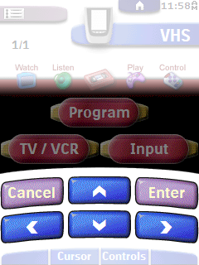
Note: The versions of EasyTheater that support TSRs with cursor control hard buttons do not include a Cursor Pop-Up, since that control is already available.

Playback Controls
Press the right center button to display the Controls Pop-Up. The Controls Pop-Up has large buttons in various configurations to match the playback control features of the home theater activity you are enjoying. The common “transport” controls appear here. All playback (and recording) controls for all activities appear on the Controls Pop-Up, making it easier to learn the locations of these controls by touch.
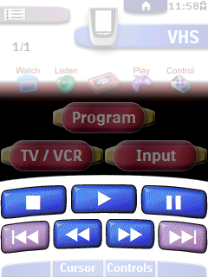

Advanced Controls
EasyTheater makes the power of your home theater simple to access, but it never restricts you from controlling even the most obscure features of your components. For nearly all Activities, the Function Well displays an “Advanced” button at the bottom of the well.
The Advanced button allows you to access button-for-button version of the physical remotes you use to control your home theater. If you find that you need a feature that is not among the EasyTheater activities, you can use the Advanced button to control your components directly. Touching the Advanced button displays a screen that lets you choose from any of the remote controls that are used with the current activity.
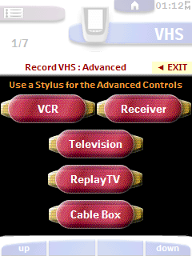
Touch any of the buttons to display a Remote Panel, a simple representation of that remote control. Because the Advanced controls are not likely to be used frequently, they are designed to be used with a stylus. This ensures that you won’t have to use multiple panels to control a component.
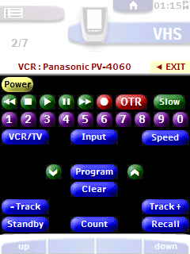

Functional Variations
Although EasyTheater was originally designed and optimized for the Pronto TSU6000, there are versions of EasyTheater for most TSRs in the Pronto family. These different versions of EasyTheater are optimized to take advantage of the various features inherent to each remote. The following sections detail these variations.
EasyTheater 6000-v1.2.ccf is optimized for Pronto TSU6000. This is the base version of EasyTheater.

EasyTheater 1000-v1.2.ccf is optimized for Pronto TSU1000. To fit in the 1MB memory space, several changes were necessary:
- No color-coded activities
- The Start page uses the regular Menu Icons instead of large icons.
- The background icons that appears on the main activities menus are smaller.
- Source Icons are not highlighted when you select them. Instead, the separator bar between the Source Well and the Function Well shows a gap to indicate which Source Icon is selected.
- To eliminate duplicate panels in the Advanced Controls areas, EasyTheater takes advantage of a quirk in the Pronto menu design to mimic a “Back” button. To exit an advanced controls screen, touch the Device menu, as shown at the top right in the screen shot below.
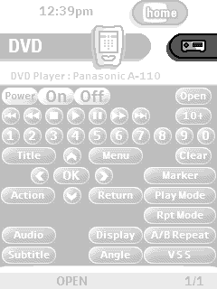
Whenever the Pronto’s Device menu appears instead of the small Exit button, use the Pronto’s Device menu as an Exit button.

EasyTheater 1000M-v.1.2.ccf is optimized for Pronto TSU1000. It uses all of the optimizations of EasyTheater 1000-v1.2.ccf, but also includes additional optimizations to further conserve memory for more complex home theater setups: Changes include:
- No color-coded activities
- All “selected” button states were removed from the graphics set on activity panels.
- No “two-across” button rows appear in the Controls Pop-Ups. These were converted to “three-across,” and a “Slow” playback button was added.
- The mid-gray set of Pop-Up buttons was replaced with the dark-gray version.
- The Start page uses the regular Menu Icons instead of large icons.
- The background icons that appears on the main activities menus are smaller.
- Source Icons are not highlighted when you select them. Instead, the separator bar between the Source Well and the Function Well shows a gap to indicate which Source Icon is selected.
- To eliminate duplicate panels in the Advanced Controls areas, EasyTheater takes advantage of a quirk in the Pronto menu design to mimic a “Back” button. To exit an advanced controls screen, touch the Device menu, as shown at the top right in the screen shot below.
Whenever the Pronto’s Device menu appears instead of the small Exit button, use the Pronto’s Device menu as an Exit button.

EasyTheater 2000-v1.2.ccf is optimized for Pronto TSU2000. It has all of the functionality of the TSU6000 version, except the following:
- No color-coded activities
- To eliminate duplicate panels in the Advanced Controls areas, EasyTheater takes advantage of a quirk in the Pronto menu design to mimic a “Back” button. To exit an advanced controls screen, touch the Device menu, as shown at the top right in the screen shot below.
Whenever the Pronto’s Device menu appears instead of the small Exit button, use the Pronto’s Device menu as an Exit button.

EasyTheater 5000-v1.2.ccf is optimized for Marantz RC5000. The larger database built into this remote requires that the graphics set be significantly reduced. Changes include:
- No color-coded activities
- All “selected” button states were removed from the graphics set on activity panels.
- No “two-across” button rows appear in the Controls Pop-Ups. These were converted to “three-across,” and a “Slow” playback button was added.
- The mid-gray set of Pop-Up buttons was replaced with the dark-gray version.
- The Start page uses the regular Menu Icons instead of large icons.
- The background icons that appears on the main activities menus are smaller.
- Source Icons are not highlighted when you select them. Instead, the separator bar between the Source Well and the Function Well shows a gap to indicate which Source Icon is selected.
- Duplicate panels were removed from the Advanced Features areas by taking advantage of the “Backward Jump” feature on this remote. Users will not see a functional difference between this method and the base version, but it saves memory and makes programming easier.

EasyTheater 5000I-v1.2.ccf is optimized for Marantz RC5000i. It includes nearly all of the base functionality of EasyTheater, with the following changes:
- No color-coded activities
- Duplicate panels were removed from the Advanced Features areas by taking advantage of the “Backward Jump” feature on this remote. Users will not see a functional difference between this method and the base version, but it saves memory and makes programming easier.

EasyTheater 5200-v1.2.ccf is optimized for Marantz RC5200. It includes nearly all of the base functionality of EasyTheater, with the following changes:
- No color-coded activities
- Takes advantage of larger screen space.
- Duplicate panels were removed from the Advanced Features areas by taking advantage of the “Backward Jump” feature on this remote. Users will not see a functional difference between this method and the base version, but it saves memory and makes programming easier.
- Does not require or use a Cursor Pop-Up, since the remote has hard buttons for this function.

EasyTheater 5200H-v1.2.ccf is optimized for Marantz RC5200. It includes nearly all of the base functionality of EasyTheater, with the following changes:
- No color-coded activities
- Takes advantage of larger screen space.
- Allows easy navigation of the EasyTheater menus using the hard buttons on the face of the remote. This increases the memory required and makes customization considerably more involved.
- Duplicate panels were removed from the Advanced Features areas by taking advantage of the “Backward Jump” feature on this remote. Users will not see a functional difference between this method and the base version, but it saves memory and makes programming easier.
- Does not require or use a Cursor Pop-Up, since the remote has hard buttons for this function.

EasyTheater 9200-v1.2.ccf is optimized for Marantz RC9200. It includes all of the base functionality of EasyTheater, with the following enhancements:
- Takes advantage of larger screen space.
- Duplicate panels were removed from the Advanced Features areas by taking advantage of the “Backward Jump” feature on this remote. Users will not see a functional difference between this method and the base version, but it saves memory and makes programming easier.
- Does not require or use a Cursor Pop-Up, since the remote has hard buttons for this function.

EasyTheater 9200H-v1.2.ccf is optimized for Marantz RC9200. It includes all of the base functionality of EasyTheater, with the following enhancements:
- Takes advantage of larger screen space.
- Allows easy navigation of the EasyTheater menus using the hard buttons on the face of the remote. This increases the memory required and makes customization considerably more involved.
- Duplicate panels were removed from the Advanced Features areas by taking advantage of the “Backward Jump” feature on this remote. Users will not see a functional difference between this method and the base version, but it saves memory and makes programming easier.
- Does not require or use a Cursor Pop-Up, since the remote has hard buttons for this function.

Modifying EasyTheater for Your Home Theater
EasyTheater was designed with easy modification in mind. The controls that are common to most home theater systems are already programmed for you. To use your own components in place of the components in the default EasyTheater file, you only need to merge your IR-only CCFs with the EasyTheater CCF, then alias the functions in the Alias Layer to the buttons from your files. (For more information, see the following section.)

The Alias and IR Layers
The key to easily customizing EasyTheater is the Alias Layer. None of the buttons on the Activity panels are programmed with IR codes. Instead, they use Alias feature of ProntoEdit to “borrow” the programming from the buttons on the Alias Layer. However, the buttons on the Alias Layer do not have IR codes either. Instead, the buttons on the Alias Layer borrow their programming from buttons on panels in the IR Layer. By serving as an intermediary, the Alias Layer makes it possible to reprogram all of the related buttons on the Activity panels by reassigning the alias of a single button.
For example, the Watch VHS Tape, Watch VCR Tuner, and Record VHS Tape activities might all have a “Channel Up” button. Each of these buttons has an alias to the VCR Channel Up button on the Alias Layer. In turn, the VCR Channel Up button on the Alias Layer has an alias to the VCR Channel Up button on the IR Layer. Only the button on the IR Layer is actually programmed with an IR code.

The Macro Layer
The Macro Layer contains buttons that are programmed with the button sequences needed to switch to the correct component inputs and states for various activities. The Source Icon buttons are programmed with aliases to the buttons on the Macro Layer. Therefore, to have EasyTheater automatically switch all of your components to the correct inputs and states, all you have to do is program a new button sequence for the corresponding button on the Macro Layer.

Globally Adjusting Delays
The buttons in the Macro Layer do not directly use the ProntoEdit Delay feature to generate delays. In place of delays, the buttons are programmed to alias the Delay Main button on the Delay panel. The Delay Main button also contains no delay; it is programmed to alias the Adjust Main button. By default, the Adjust Main button is programmed with a 0.1 second delay.
This structure makes it possible to adjust the playback speed of all of the macros in the Macro Layer by changing the delay in only one button: the Adjust Main button.
The macro sequences are programmed to alias the Delay Main button instead of directly aliasing the Adjust Main button to allow you to remove the delays entirely without eliminating the ability to use delays later on. If the macros aliased the Adjust Main button, and you wanted to try a zero delay, you would have to either delete the Adjust Main button or go into each macro and delete all aliases to the Adjust Main button. It would then be quite a lot of work if you wanted to use a delay again later. EasyTheater eliminates this problem by having Delay Main alias Adjust Main. You can use a zero delay by editing the Delay Main button and removing the alias to Adjust Main. If you want to use a delay later, just alias Delay Main to Adjust Main again.
The Delay Fav and Adjust Fav buttons operate exactly like the Delay Main and Adjust Main buttons, but are used to adjust the timing of the Favorites macros.
The Delay Power and Adjust Power buttons operate exactly like the Delay Main and Adjust Main buttons, but are used to adjust the timing of the All-On and All-Off macros.

Using Your Own Components
The Alias Layer allows the EasyTheater CCF to operate independently of the IR codes for your components. By re-alaising the buttons on the Alias Layer to the buttons on the IR Layer, you can easily replace an existing component with a new one.
To replace a preprogrammed component with your own component:
  - In ProntoEdit or Touch Screen Setup, create a CCF with that contains a single device for your new component. The buttons should mimic all of the buttons on the physical remote control you are replacing.
  - Program IR codes or use your existing remote to learn IR codes for all of the buttons in your single-device CCF.
  - Save your new CCF.
  - Open the EasyTheater.CCF file. When ProntoEdit or Touch Screen Setup asks you if you want to Replace or Merge with the current CCF, choose Replace.
  - In the EasyTheater IR Layer, delete the device for the preprogrammed component you want to replace.
  - With the EasyTheater CCF still open, open the CCF for your new device. When ProntoEdit or Touch Screen Setup asks you if you want to Replace or Merge with the current CCF, choose Merge.
  - Locate the device for your new component and drag or copy it to the IR Layer.
  - Open the device in the Alias Layer that corresponds to the component you are adding. For example, if you are adding a VCR, open the VCR device in the Alias Layer.
  - Edit the Action of each button, creating an alias to the corresponding button on your device. For example, the VCR Play button on the Alias Layer should be programmed with an alias to the VCR Play button on your new component device.
  - Save the EasyTheater.CCF file with a new file name to preserve the original EasyTheater.CCF file.
When you finish re-aliasing all of the buttons on the Alias Layer, all of the activity buttons that are programmed to alias the Alias Layer are now automatically programmed to emit the IR codes from the new component device you added.

Favorites Buttons
For many devices, the Alias Layer contains a set of preprogrammed “favorites” buttons. Panels in the Activity Layer alias these favorites buttons, which send the button sequences to select your favorite channels. You’ll also find a “Build” button that makes it easy to program your favorites into the included buttons.
The Build button is preprogrammed with aliases of two copies of each digit for the correct device. Instead of needing to search through the list of devices and panels in ProntoEdit, you can simply copy the programming of the Build button to a Favorites button, delete the unnecessary digits, then drag the remaining digits to their correct order.
Tip: To save time, all Favorites buttons in the default EasyTheater file are programmed with the same programming as the Build button. This lets you easily program your own favorites.
Favorites buttons are on the Alias Layer, but the buttons they are programmed to alias are always in the same device on the Alias Layer, not on the IR layer. This ensures that you won’t need to reprogram your favorites buttons if you later replace one of your components with a new one.
To Reprogram a “Favorites” button:
  - On the panel that contains the Favorites button, Shift-drag the Build button to the Favorites button you want to reprogram.
  - Double-click the Favorites button you want to edit, then choose the Action tab.
  - Delete any digits you do not need. For example if you are programming channel 142, delete all digits except one “1,” one “2,” and one “4.”
  - Drag the remaining digits to their correct order in the sequence. For example, if you are programming channel 142, drag the “4” above the “2.”
  - If your component requires delays between the digits, drag the delays in between the digits. Otherwise, delete them.
  - Click OK to finish.

Understanding the File Structure
When you examine the EasyTheater CCF file, you may find the structure to be somewhat unusual. The menu system of EasyTheater uses multiple levels of hierarchy, while ProntoEdit allows only two levels of hierarchy.
To understand the EasyTheater file structure, you should essentially ignore the “Device” and “Macro” headings in ProntoEdit. The file structure of EasyTheater “overlays” the CCF file structure to mimic replacing it with several conventions. These conventions are described in the following sections.

Devices and Panels
ProntoEdit and Touch Screen Setup let you program the TSR hard buttons on a device-by-device basis. EasyTheater simulates a device-independent windowing system by ignoring the Device aspect of the CCF format, often using only one panel per “device.” Because some Activities require many panels, you will see the same Device names listed multiple times. This is a side-effect of the CCF format’s two-tier hierarchy—a result of forcing the CCF format to allow panel-by-panel control of the hard buttons.
To conserve memory, Activities that do not require Pop-Ups have multiple panels in a single CCF device.

Layers
EasyTheater is organized in “layers” to group related activities.
Menu Layer Contains the main menus collected into a single Menu device, and separate menus for each Menu Icon, each in separate devices.
Watch Layer Contains panels used to watch various video sources.
Listen Layer Contains panels used to listen to various audio sources.
Record Layer Contains panels used to record various video sources.
Play Layer Contains panels used to play various video game consoles.
Control Layer Contains panels used to control lights and other electrical devices. Also contains panels used to access the remote controls used by the entire home theater.
Alias Layer All buttons in all Activities alias the buttons in the panels on this layer. The buttons on this layer are aliased to the panels in the IR layer.
IR Layer Contains panels that have direct button-for-button recreations of the physical remotes for the home theater. The buttons on this layer are the only buttons that actually contain IR codes. However, these buttons are never aliased directly from the Activity panels. Instead, all Activity buttons alias buttons on panels found on the Alias layer.
Macro Layer Contains panels with buttons that have macros to power on, power off, and switch to the various states needed for Activities.

Advanced Panels
On Philips color TSRs, the Advanced button found in each Function Well jumps to duplicate copies of the panels in the IR Layer, instead of the actual panels in the IR Layer. Unfortunately, ProntoEdit does not support simple “Return to Previous Panel” or “Back” commands. This makes it impossible to use the same set of Advanced panels for all activities and still make it easy to return to the Activity panel where you touched the Advanced button.
To simulate this capability, EasyTheater contains near-duplicates of the panels in the IR Layer within each Activity. This allows the “Exit” button on each Advanced panel to return to the menu where the Advanced button was touched.
Because the use of duplicate panels is memory-intensive, EasyTheater does not use duplicate panels on grayscale Prontos. Instead, the EasyTheater CCF is set up to use the Device menu to mimic a “Back” button. Touch the Device menu to exit an advanced controls screen on a grayscale Pronto.
Marantz TSRs do support a “Back” jump. If you’re using a version of EasyTheater for a Marantz remote, the Exit buttons on the IR Layer panels use the “Back” jump to return to the appropriate panels.

